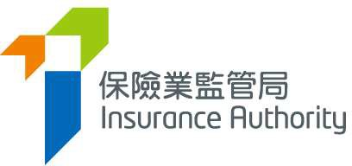
香港黃竹坑香葉道41號19樓
19/F, 41 Heung Yip Road, Wong Chuk Hang, Hong Kong
電話 Tel: (852) 3899 9983 電郵 E-mail: enquiry@ia.org.hk
傳真 Fax: (852) 3899 9993 網址 Website: www.ia.org.hk

12 April 2024 By Email Only
Our Ref:

To: Chief Executives of All Authorized Insurers

Dear Sirs,

GL4: Guideline on “Fit and Proper” Criteria in relation to Authorized Insurers under the Insurance Ordinance (Cap. 41)

Pursuant to section 133 of the Insurance Ordinance (Cap. 41), the Insurance Authority (“IA”) has published a revised Guideline on “Fit and Proper” Criteria in relation to Authorized Insurers under the Insurance Ordinance (“GL4”). Enclosed please find a copy of the revised GL4 which is also available on the https://www.ia.org.hk/en/legislative_framework/guidelines.php.

The GL4 is revised in view of the enactment of the Insurance (Amendment) Ordinance 2023 (“Amendment Ordinance”). Among others, amendments include to elaborate the “fit and proper” criteria for majority shareholder controller, to elaborate the qualification and experience requirement for certifying actuary in relation to general business, and to elaborate the assessment of internal control and corporate governance structure for body corporates.

Comments from the industry have been incorporated into the revised GL4 where appropriate. The revised GL4 shall take effect from 1 July 2024, along with the commencement of the Amendment Ordinance.

Should you have any queries in relation to the above, please contact your case officer or email us at rbc@ia.org.hk.

Yours faithfully,

Clement Lau
Executive Director
Policy and Legislation Division
Insurance Authority

Encl.

c.c. Chairman, The Hong Kong Federation of Insurers
President, The Actuarial Society of Hong Kong

https://www.gld.gov.hk/egazette/pdf/20232728/es12023272820.pdf

